

**BT4016 Risk Analytics for Financial Services**

**Semester 1 AY 20/21**

**Portfolio Risk Management Project**

**Midterm Report**

***Group 10***

**Prepared by:**

Chew En Ren Janson (A0183927R)

Ho Ying Rong (A0188843M)

Koh Kai Jie Bryan (A0183858L)

Lim Jermaine (A0187866E)

Timothy Lim Shyen En (A0167597H)

As an aggressive investor, Kris is willing to tolerate higher levels of risk in exchange for potentially greater returns. Quantitatively, he is willing to accept the VaR (5%) of his portfolio to be no greater than 20% while maximising expected returns.

We optimize our portfolio by minimising risk and maximising returns. We minimise the following objective function to achieve a desired trade-off between return and risk.

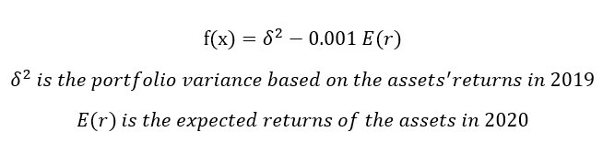

The optimisation is subject to multiple constraints:

1. Group constraint: Constraints are imposed on the sum of weights based on the market capitalization of assets. In the initial report, we noted that better performing funds saw more market cap diversification. To avoid situations where large-cap stocks are overweight, we introduced constraints on the weights assigned to different classes of stock based on their market cap. We classify large-cap stocks with market cap over $10 billion, mid-cap stocks with market cap between $2 billion and $10 billion, and small-cap stocks with market cap less than $2 billion.[1] We set the portfolio’s exposure to large-cap, mid-cap and small-cap stocks to be no more than 10%, 60% and 30% respectively. This allocation is similar to that of our selected best portfolio, ETIHX. While small-cap stocks are more volatile than larger caps, yet they have greater growth potential and tend to offer better returns over the long term.[2] This fits with Kris’ investor profile.
2. Box constraint: Assuming long only positions, each weight must be positive. For risk management purposes, the maximum amount allocated to an individual asset is 20%.
3. Sum of weights constraint: As per the requirements, we invest all our capital. Thus, the summation of all asset weights must be equal to 1.
4. Benchmark return constraint: The performance of our portfolio is benchmarked against the **Nasdaq Biotechnology Index (^NBI),** which is tracked by the **iShares Nasdaq Biotechnology Index (IBB)[3]**. As we are seeking to outperform our benchmark, the returns from the portfolio optimization should be at least equal to the returns of the benchmark. If our optimised portfolio could not yield a better in-sample result than the benchmark, it would suggest that Kris is better off holding the benchmark index instead.
5. VaR constraint: Kris is willing to accept 5% VaR of up to 20%. We assumed the following for this constraint:

* Mean returns of the portfolio is equal to 0.
* VaR is calculated using a parametric approach, returns are normally distributed

The standard deviation of the portfolio should be no greater than 20% / 1.66. To satisfy

the convex requirements of the optimisation, we set the constraint as the variance of the portfolio to be no greater than the square of (20% / 1.66). Given the bullish performance of the biotech sector in 2019, the first assumption would yield a more conservative estimate as assuming mean returns equal to 0 would yield a larger estimate for VaR than if we had used the observed mean returns.

These constraints ensure our constructed portfolio has in-sample performance at least equal to the benchmark portfolio. Further constraints on the maximum weight assigned to an individual stock help to manage risk by avoiding overexposure to any firm-specific shocks. Lastly, we incorporated our observations on the size of companies’ market capitalisation and the performance of portfolios as a constraint.

**Worst Mutual Fund**

As no information is available regarding the holdings of SHPCX in 2019, we changed our worst performing mutual fund to **Rydex Biotechnology Fund** **(RYCFX)**. The RYCFX has a Lipper Leader rating of 1/5 and 2/5 for total returns and consistent returns respectively, indicating poor performance. As mentioned in the earlier report, RYCFX is also overweight in large-cap biotech companies and underweight in small-cap companies. This does not fit with Kris’ investor profile as he is willing to accept additional risk for potentially greater returns. Hence, we chose to use RYCFX as the new worst performing mutual fund.

**Adjustment of Expected Returns**

Before optimizing the portfolio, we check the historical returns of our selected assets for extreme values. Due to the nature of biotechnology stocks, we see that historical returns for some stocks were exorbitant. Returns can be as high as 300%. Using realized historical returns for portfolio optimization may yield unrealistic results. Therefore, we made reasonable adjustments on the expected returns of our stocks based on the target prices forecasted by analysts[4] using the Black-Litterman (BL) model. The model is used as a framework to blend market-implied returns with analysts’ forecasts to output a prediction for the expected value of the asset in 2020.

Firstly, we obtained the market-implied equilibrium returns as our ‘priors’. Using ^NBI as a proxy for the market, we derive the equilibrium returns based on the assets’ market capitalisation weight. In the absence of additional information, these equilibrium returns would be used as the expected returns.

Next, we obtained the consensus of various analysts’ target prices as of the end of 2019. The analysts’ target prices are taken to be the price of the asset in 2020. Based on this assumption, we calculated the expected return based on the asset prices at the end of 2019. The expected return for the ith asset used in the BL model is calculated as

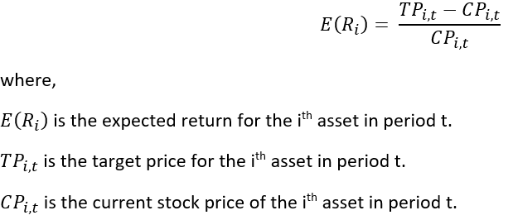

To construct the uncertainty matrix Ω, we used the Idzorek's method, which is an intuitive method where investors’ can specify their confidence level between 0% and 100% with regards to the target prices (views). This helps investors control the magnitude of the tilts caused by the views. The higher the assigned confidence, the greater the final prediction will be to the returns based on the target prices. Analysts tend to be bullish in their outlook and are likely to overstate the target prices. To account for this bias, we capped our confidence level for any stock’s target price to be 50%. For expected returns that are higher than 50%, we assigned a slightly lower confidence of 30%.

Finally, using the price target expected returns as our views, we combine it with our priors to derive the posterior estimates of expected returns. These estimates would be used as an input to our optimisation. The results of our optimization can be seen in figure 1.

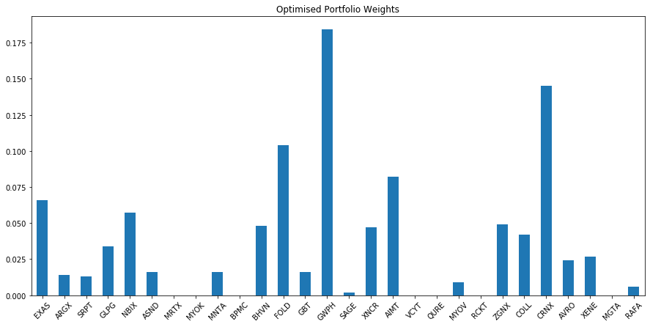

Figure : Optimised Portfolio Weights

The statistics for the respective portfolios are reported in the table below.

|  |  |  |  |  |
| --- | --- | --- | --- | --- |
|  | **Best** | **Worst** | **Index** | **Optimised Portfolio** |
| Sharpe Ratio (1 year) | 3.56 | 1.39 | 1.12 | 1.46 |
| Alpha (1 year) | 0.0043 | -0.0016 | - | 0.0013 |
| Annualised Return (2019) | 0.99 | 0.26 | 0.22 | 0.37 |
| Annualised Risk (2019) | 0.28 | 0.19 | 0.20 | 0.26 |
| Fee Expense | 0.0129 | 0.0248 | N.A. | N.A. |
| Turnover Rate | 0.33 | 0.64 | N.A. | N.A. |

The VaR (5%) and Expected Short-fall (5%) are reported in the table below.

|  |  |  |  |  |
| --- | --- | --- | --- | --- |
|  | **Best** | **Worst** | **Index** | **Optimised Portfolio** |
| VaR (Parametric) | 0.027 | 0.019 | 0.020 | 0.025 |
| VaR (HS) | 0.023 | 0.018 | 0.020 | 0.025 |
| ES (Parametric) | 0.038 | 0.025 | 0.027 | 0.034 |
| ES (HS) | 0.035 | 0.025 | 0.027 | 0.032 |

**Discussion**

*In-sample Analysis*

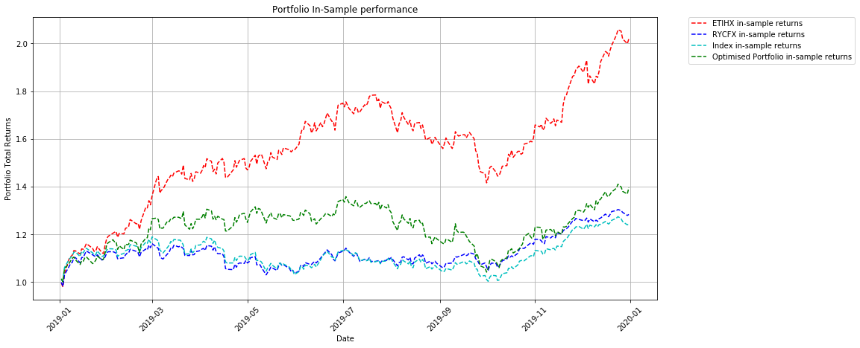

Figure : In-sample returns

First, we analyse our in-sample portfolio performance (figure 2). As expected, we observe that the best portfolio **(ETIHX)** we had previously selected performed the best in 2019. We are not overly-concerned with having a good in-sample performance as optimising on this metric would lead to overfitting on the asset performances in 2019. The results of our optimisation process were verified by using the expected returns based on the BL model. Our optimised portfolio did indeed give a higher return (28.9%) compared to the weights assigned by ETIHX (24.0%). Using 2019 volatility as a proxy for future volatility, our optimised portfolio also had marginally lower risk (1.61%) compared to ETIHX (1.77%).

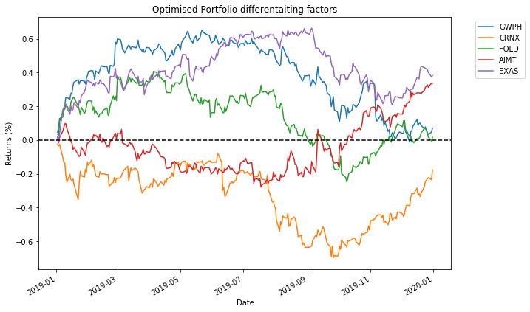Next, we analysed the different weightage given to the various assets by our optimisation process. We identified the assets that caused the largest points of difference between the two portfolios by comparing the absolute differences in assigned weight. Plotting the returns of these assets in 2019, we get a better understanding of what caused our optimised portfolio’s poorer in-sample performance.

From figure 3, we observe that these assets saw a drop in their returns around August 2019. This corresponds to the drawdown of our optimised portfolio during this period. Analysing the adjusted returns for these assets, it becomes apparent why our optimisation selected these assets.

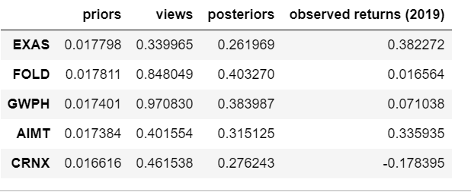The posteriors in figure 4 represent our expected returns for these assets. We observe that the posteriors are generally larger than the observed returns in 2019, especially for FOLD, GWPH and CRNX. This accounts for the selection of these assets despite their relatively poorer in-sample performance.

Figure 4: Expected and Observed Returns for Optimised Portfolio

Figure 3: Optimised Portfolio differentiating factors

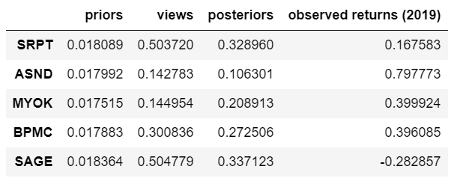Figure 5 shows the assets which ETIHX had assigned more weightage to. We observe that the posteriors are generally lower than the observed returns in 2019, especially for ASND which returned 79.7% in 2019. Yet, the BL model had only predicted a future return of 10% for this asset. This makes sense as we do not expect such high returns to continue in the future.

Figure 5: Expected and Observed Returns for ETIHX Portfolio

*Out of Sample Analysis*

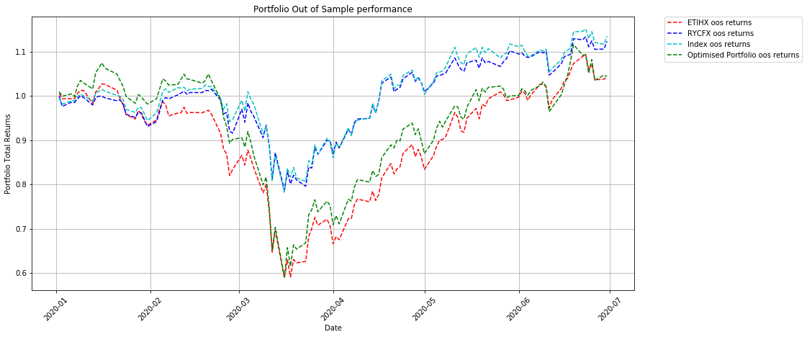

Figure 6: Out-of-sample returns

In figure 6, we observe that both our optimised portfolio and ETIHX performed significantly worse than RYCFX. This is likely due to RYCFX’s portfolio generally comprises larger companies who were able to better weather the sudden onset of the COVID-19 pandemic. Comparing our optimised portfolio against ETIHX, their performances are almost identical despite assigning different weightages to various assets.

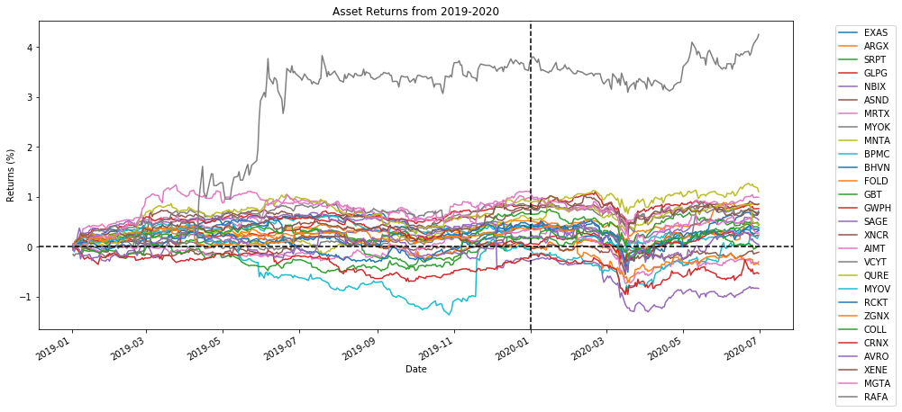

Figure 7: Asset Returns

The reasons for their identical performance become apparent when we plot the individual asset returns in 2020. In figure 7, we observe that the assets appear to have moved in tandem with each other for the first 6 months of 2020. Our visual analysis is confirmed when we plot the correlation matrix, observing significantly higher correlation in 2020 as compared to in 2019. This strong correlation indicates a high systemic risk associated with our selected basket of assets. Diversification effects will not be as effective while employing a long-only strategy.

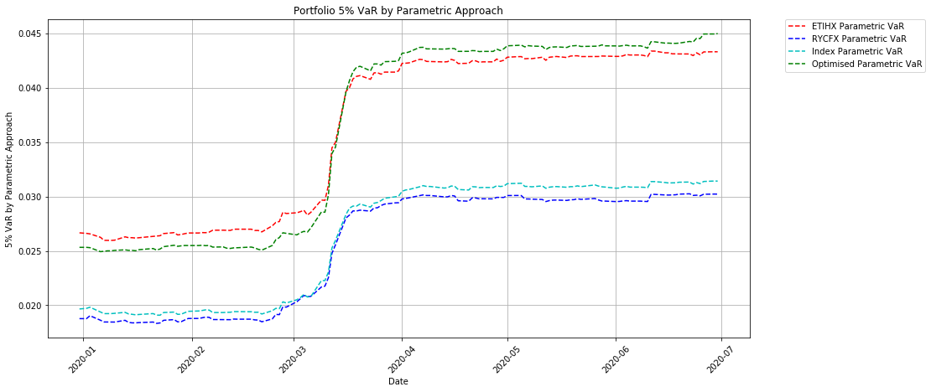

Figure 8: Portfolio 5% VaR by Parametric Approach

In figure 8, we also observe that our portfolio’s VaR was significantly higher after March 2020. Historical volatility observed in 2019 was not a good proxy for predicting future volatility in 2020. The risk of our portfolio also increased from 25.6% in 2019 to 56.4% in 2020.

*Limitations of current approach*

Firstly, our optimisation is largely dependent on the output of the BL model. There is a considerable amount of subjectivity in this framework when deciding which analysts’ target prices to select and the respective confidences assigned. While our approach is quantitative in output, there are still some qualitative aspects (eg. how much weight to give an analyst’s prediction) which requires specific domain knowledge.

Next, the basket of assets we consider for our optimisation have a strong systemic risk associated with each of them. This is by design of the problem, as we have constrained our project to selecting assets from a specific sector. As seen in 2020, the risk associated with these assets was systemic and there was little firm-specific risk observed. In this scenario, asset diversification alone may not be the most effective risk management strategy. Other risk management strategies, such as hedging, may be considered.

**Further Adjustments**

To make further adjustments to our ‘optimal portfolio’, we modify the assigned weights after looking through the current pipeline of each company. An understanding of the company’s pipeline and the phases a company’s drug candidates are in also provides investors means to evaluate the risks and returns involved. The following 2 companies show a positive outlook and should be assigned a higher weightage:

1. Galapagos NV **(GLPG)**, current portfolio weight: 3.4%
2. Neurocrine Biosciences **(NBIX),** current portfolio weight: 5.7%

Firstly, GLPG has made substantial progress in the past few months despite the global pandemic. In addition to seeing “positive topline data for the SELECTION Phase 3 program in ulcerative colitis (UC)”, they have also added 2 more preclinical candidates to their pipeline and finished preparing for multiple new clinical trials. Although GLPG’s market value suffered a drop earlier due to failure in obtaining approval from FDA for filgotinib, the “positive opinion from a European Medicines Agency committee”, gives us greater confidence in seeing a breakthrough[5]. Not to mention, the significant unmet needs of patients with rheumatoid arthritis will continue to drive the demand for filgotinib and this makes us optimistic about the growth potential of GLPG.

Secondly, NBIX investors can look forward to a boost in revenues following the launch of the new Parkinson's Disease drug, Ongentys. Having successfully overcome the supply chain bottleneck, NBIX is ready to market Ongentys, which is to be consumed together with levodopa, as COVID-19 restrictions are being relaxed gradually. Notably, the demand for Ongentys would be quite significant because more than 60% of Americans with Parkinson's disease are currently taking levodopa[6]. With a $590 per month price tag, the launch of Ongentys will undoubtedly push up revenues for NBIX.

On the other hand, we reduced the weight allocated to GW Pharmaceuticals **(GWPH)** and Crinetics Pharmaceuticals **(CRNX)** due to the relatively high uncertainty on how the company will perform in coming periods with the ongoing pandemic. Our current portfolio assigned 18.4% and 14.5% to these assets respectively - the highest in the portfolio. Although Kris has a long investment horizon and could possibly ride out these uncertainties, we cannot ignore a plausible downturn of the COVID-19 situation in the US[7]. The skepticism on the companies’ performance will remain high when there are little improvements to the COVID-19 situation. We can expect clinical trials and preclinical studies to be disrupted and employees productivity could also be impaired with the pandemic. With this in mind, we should be prudent and not overweight on these 2 stocks. Hence, GWPH and CRNX weightage are being moderated and reduced.

1. https://www.fool.com/investing/how-to-invest/stocks/what-is-market-cap/
2. https://www.investopedia.com/ask/answers/022715/are-small-cap-companies-more-risky-investments-large-cap-companies.asp#:~:text=Small%2Dcap%20companies%20tend%20to,negative%20events%20and%20bearish%20sentiments.
3. We had previously selected the MSCI World Pharmaceuticals, Biotechnology and Life Sciences Index as a benchmark. However, we were not able to obtain historical data for that index. Thus, we have selected the Nasdaq Biotechnology Index as our new benchmarking portfolio.
4. <https://www.marketscreener.com/quote/stock/EXACT-SCIENCES-CORPORATIO-9232/consensus/>

   The target prices are obtained from MarketScreener, where consensus price targets are an average of price targets set by each analyst for the stock in the last 18 months.
5. <https://www.bloomberg.com/news/articles/2020-08-19/galapagos-suffers-biggest-fall-ever-as-fda-fails-to-approve-drug>
6. <https://www.fool.com/investing/2020/09/14/neurocrine-officially-begins-marketing-new-parkins/>
7. <https://www.thecut.com/2020/10/which-states-have-coronavirus-and-how-do-you-minimize-risk.html>